AZURE SQL DATABASE

Activity:

1. Setting up an azure SQL database.

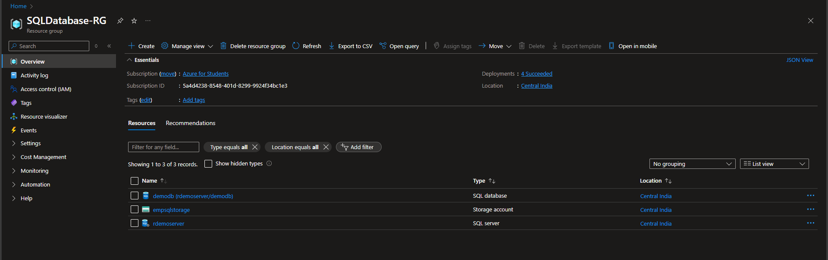

1. Connect to the newly created azure SQL databaseusing SQL Server Management Studio (SSMS).

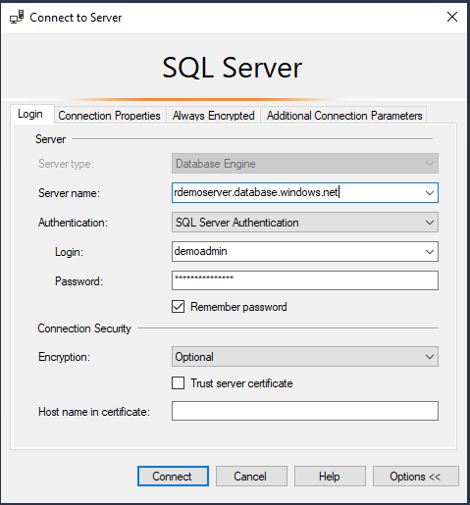

1. Write a SQL query to create, insert, select, update and delete, truncate and drop in SSMS.

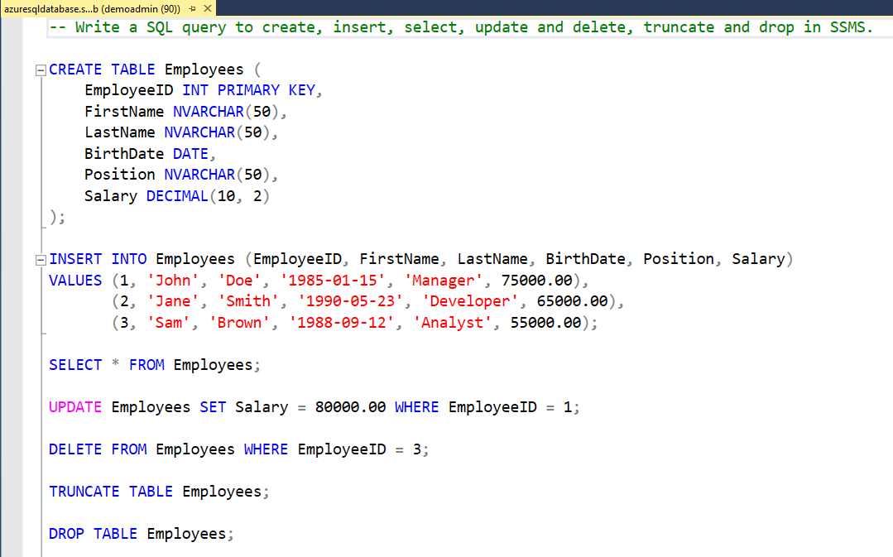

1. Create an index on a table to improve query performance



1. Use SQL Server Management Studio (SSMS) to export data from your database to a .bacpac file.

